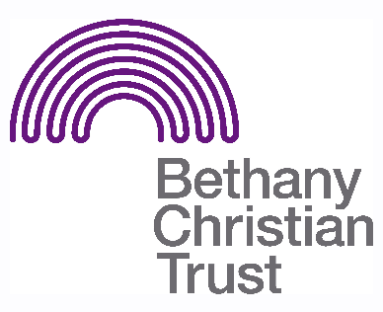
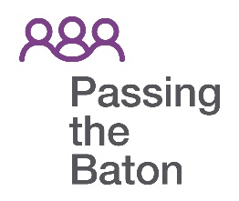

Title: Passing the Baton Befriender
Basis: Volunteer
Safeguarding: Volunteers are disclosure checked by Bethany Christian Trust

Responsible to: Passing the Baton staff
Responsible for: Supporting individuals to make community connections

Summary of the role:
A trustworthy and compassionate individual, willing to befriend a person who is socially isolated and may also struggle with addiction, homelessness and mental health issues; creating a healthy, meaningful relationship; encouraging and practically helping them to make at least 2 community connections with the support of Passing the Baton staff.

General responsibilities:
- Develop a companionship level relationship with their befriendee (we match male-male and female-female)
- Accompany the befriendee to social activities and community groups. Befrienders do not go into the befriendee’s home
- Participate in induction and on-going training as appropriate and adhere to all procedures and policies
- Send number of hours you spend with the befriendee, on a monthly basis, to Passing the Baton staff.

Important pre-requisites for the role:
- Be 18 years old or over
- A person of Christian faith, rooted in a Christian community
- A befriender should have integrity, be reliable and non-judgemental and be aware of confidentiality issues which may arise regarding the individual. We work with people of all faith and no faith.
- Be able to operate under the guidance and support of Passing the Baton staff
- Be sociable and have an approachable manner
- Have good time management and organisational skills

Location
- We operate within Edinburgh
- As far as possible, we will try and match you to a befriendee who is geographically close to you.

Pattern of hours
- It may be necessary, for the first 2-3 months, to meet up with the befriendee for 1.5 – 2 hours every 1-2 weeks to build a relationship before taking them to a group.
- We recommend, in the early stages, staying with the befriendee when visiting a new community group for the whole time, then gradually reducing your time.
- Where possible, we encourage you to meet during Bethany office hours (Mon-Fri, 9am-5pm) to ensure a staff member is available in case of emergency.

Training and support available
- All befrienders will receive the necessary Passing the Baton training before becoming a befriender
- Befrienders are encouraged to come to additional training and support evenings
- Passing the Baton staff will contact befrienders to offer help and support as and when required.
- Befrienders are encouraged to contact Passing the Baton staff if they have any problems or if staff can be of assistance to the befriender or befriendee.
- Passing the Baton staff can provide befriending cover, such as when befrienders go on holiday or are ill.
- Expenses can be reimbursed in accordance with Bethany’s volunteer policy

Reviewed Nov 2021

