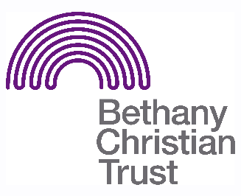

Title: Social Media Volunteer
Basis: Volunteer
Safeguarding: No PVG check required

Responsible to: Volunteer Development Coordinator
Responsible for: Promoting volunteering opportunities and raising awareness of Bethany’s work

Context of the role:
We are looking for a Social Media Volunteer to support the Volunteer Coordinator in managing different social media channels, with the aim to promote volunteering with Bethany and raise awareness of our work across Scotland.

General responsibilities:
As Social Media Volunteer, you will be involved in:
- Maintaining active social media accounts (Instagram, Twitter)
- Crafting creative content to promote Bethany’s volunteering opportunities
- Thinking of innovative ways to reach a wider audience and increasing awareness of Bethany’s work

Important pre-requisites for the role:
We are looking for a volunteer who:
- Has experience of producing original content on online platforms, specifically Instagram and Twitter
- Has an understanding of how to interact with people on social media
- Has basic design knowledge to create images for social posts, especially on Canva
- Has strong communication skills and attention to detail

Location:
Volunteering will take place in our office in Leith.

Pattern of hours:
Volunteering will take place between 9am-5pm from Monday to Friday, but the specific hours will depend on the volunteer. We will work around your schedule and what spare time you have.

Expenses:
Volunteers are entitled to claim up to £3.60 per day for travel expenses (£4.50 if multiple busses are required) and up to £3 per day for lunch expenses, providing that they volunteer for 4 hours or more on that day, and that they present the receipt to their supervisor.

