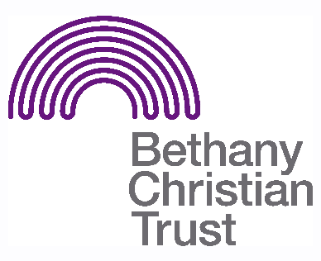

Title: Women’s Group Volunteer
Basis: Volunteer
Safeguarding: No PVG checks necessary. There is a minimum age limit of 18 for volunteers at this group.

Responsible to: Passing the Baton staff
Responsible for: Helping with the running of the Women’s Group

Summary of the role:
The Women’s Group is a place for fellowship, support and encouragement. Volunteers are required to help facilitate this in a variety of ways.

General responsibilities:

- A volunteer would need to set up the hall for use during the group, and prepare food and drinks in the case of a special celebration, e.g. Burns Night. After the group has finished, the volunteer is also expected to assist in cleaning and housekeeping. For this reason, a volunteer should arrive on time and give as much notice as possible if they are unable to volunteer.
- Helping to make the individuals attending the group to feel welcomed and comfortable. This can be through serving food and drinks, facilitating activities or having a chat. The volunteer should balance this with being aware of boundaries.
- At times, and where appropriate, a volunteer may need to take the lead on preparing and/or supervising an activity, though always with the supervision and support of Passing the Baton staff. Volunteers are encouraged to use their knowledge and skills to support Bethany staff to create an activities programme.
- Help to facilitate and organise trips (if there is a desire to do so).
- Signpost individuals who are seeking support to staff or to other relevant services.
- Alert a staff member in the group if you have concerns about an individual or situation within the group
- We work in an asset-based way so we would encourage our volunteers to work in this way and make sure voices are heard.

Important pre-requisites for the role:

- Having a particular skill or talent (e.g. playing the guitar) can be really useful.
- Ideally, a volunteer would have experience of working with individuals with mental health issues and or addiction issues.
- The volunteer would need to be reliable and willing to commit to building stable connections with clients.
- The role may be challenging, and so the volunteer must be patient, understanding and willing to be proactive in engendering a positive environment.
- Though the role does not require the volunteer to be a Christian, they must be aware and respectful of the Christian ethos upon which Bethany Christian Trust is founded.

Location
- Bethany Christian Trust’s Learning Centre – 65 Bonnington Road, Edinburgh, EH6 5JQ

Pattern of hours
- The group runs every Tuesday Afternoons every week except the first Tuesday of the month. Exact timings to be discussed.

