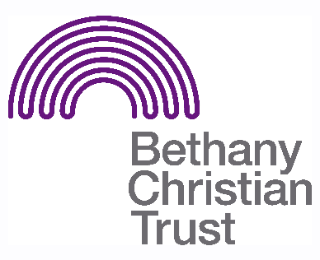

Title: Menzieshill Connect Café Volunteer
Basis: Volunteer
Safeguarding: No PVG required. Volunteers must be over 18.

Responsible to: Homelessness Prevention Senior Community Development Worker

Responsible for: Supporting the running of the Connect Café, a Drop-In café based
in Menzieshill.

Context of the role:
Bethany aims to tailor projects to the particular requirements and resources of each area, engaging with communities to revitalise areas where the potential for homelessness is a real concern. Staff and volunteers work to discover, connect and mobilise individuals to see lasting change in their own lives and that of the community, both personally and professionally. The Connect Café is part of that work.
Summary of the role:
The Connect Café is run in partnership with Menzieshill Parish Church, Crossreach and Bethany Christian trust. It is run by volunteers from the community for the benefit of the community. The café has been set up to provide volunteer opportunities and support for those in recovery. The term ‘recovery’ is used to apply to all who are going through, or have been through, something that they are recovering from, including poor mental health, addiction, unemployment etc. The café offers free healthy food and a friendly social space that all Menzieshill residents can access, along with additional support from recovery and addiction workers and a well-being nurse.
We require volunteers who are able to help with the set up and running of the café, including supporting those who use the café and who are looking to get volunteer experience.

General Volunteer Responsibilities:
- Help set up the hall for use during the cafe, and prepare food and drinks. During the café the volunteer would assist in serving food and drink. After the group has finished, the volunteer is also expected to assist in cleaning and housekeeping. For this reason a volunteer should arrive on time and give as much notice as possible if they are unable to volunteer.
- Help make individuals attending the cafe to feel welcomed and comfortable. This can be through serving food and drinks, facilitating activities or having a chat. The volunteer should balance this with being aware of boundaries.
- Encourage and support those who use the café who are also looking to help out at the café.
- At times, and where appropriate, a volunteer may need to take the lead on preparing and/or supervising an activity, though always with the supervision and support of the Community Development Worker. Volunteers are encouraged to use their knowledge and skills to support Bethany staff in developing the cafe.
- Signpost individuals who are seeking support to staff or to other relevant services.
- Alert a staff member in the cafe if there are concerns about an individual or situation within the group.

Kitchen Volunteers Responsibilities:
- Prepare cakes, soups and other foods
- Ensure that the kitchen remains clean and tidy
- Support and guide volunteers as they assist in preparing food, and ensure correct preparation and hygiene protocols are followed
- Take orders from customers, preparing and serving

Important pre-requisites for the role:
- For the kitchen role, experience in a commercial kitchen is an asset. Volunteers for the kitchen should have a relevant Food Safety certificate or be prepared to go through this training.
- Volunteers must be confident, friendly and encouraging.
- Volunteers who also use the Café may be nervous or unsure as they learn. Bethany volunteers should be sensitive to this and support as necessary.
- The role may vary week to week. Volunteers should be adaptable and able to take initiative.
- Though the role does not require the volunteer to be a Christian, they must be aware and respectful of the Christian ethos upon which Bethany Christian Trust is founded.

Location:
- Menzieshill Parish Church, Charleston Drive, Menzieshill, Dundee, DD2 4BD

Pattern of hours:
- Volunteers are needed on a Wednesday 11:00am – 3:30pm

Last updated July 2023

