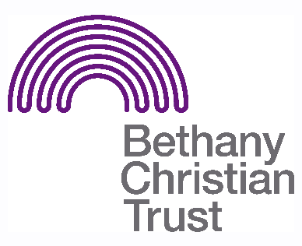

Title: Homework Club Volunteer
Basis: Volunteer
Safeguarding: PVG check required

Responsible to: Moredun Community Builder
Responsible for: Supporting the running of a Homework Club, providing a safe space for children and families to get support with school work

Context of the role:
Bethany provides a suite of services which support people struggling with issues of homelessness helping them to: find suitable accommodation and furnish their homes, tackle addictions, learn new skills and gain employment, develop positive social networks and become active members of their local communities. This role is part of Homelessness Prevention, specifically the community work done in Moredun. The aim of this project is to help children, with their homework, as well as supporting parents and carers.
Summary of the role:
Building and supporting resilient communities is a key part of the work done at Bethany Christian Trust. One way to do this is assisting children with their homework, whilst also supporting their parents/ carers and helping them to connect into the local community. The group is currently for Primary School children.

General responsibilities:
- Working in both a group setting and one-on-one, the volunteer will support the children in completing their homework.
- Where specific homework has not been set by the school, the volunteer will support those attending with additional educational resources, including games and activities. There may be a small amount of preparation required for this and the volunteer should support and encourage the children to take part in any activities.
- Parents and carers may also attend the group and should be supported and made to feel welcome. These adults may have a number of additional support needs, such as English as an additional language or mental health concerns. Where parents and carers are present, the volunteer will work with them to help them support their child in completing their homework.

- The volunteer will support staff in implementing health and safety procedures and refer to Bethany staff should they have concerns about an individual or situation within the group

Important pre-requisites for the role:
- In working with children and their families, several of whom are learning English, the volunteer will need to be an adept & patient communicator.
- Children can get frustrated or distracted and the volunteer would need to be able to guide them to the task at hand, while still making the session a positive experience.
- Ideally, the volunteer would have worked in, or have experience of, the educational field and working with vulnerable families.
- The volunteer should be enthusiastic and welcoming, whilst also being aware of appropriate boundaries.
- Volunteers must complete the necessary induction for this role.
- Help to set up the room for use during the group and prepare refreshments. After the group has finished, the volunteer is also expected to assist in cleaning and housekeeping. For this reason a volunteer should arrive on time and give as much notice as possible if they are unable to volunteer.

- Volunteers must be comfortable and in sympathy with our mission and values: “Our Mission is to relieve the suffering and meet the long-term needs of homeless and vulnerable people in Scotland while our values are to put Christian love into action and demonstrate the transforming impact of the Gospel in all that we do.”

Location
- The group runs in the Goodtree Neighbourhood Centre in Moredun, Edinburgh (EH17 7LB)
Pattern of hours
- The group runs on a Wednesday, 3.30-4.30pm during term time

