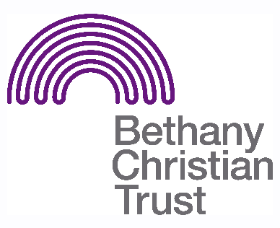

Title: Clay Café Volunteer
Basis: Volunteer
Safeguarding: No PVG required. Volunteers must be over 18.

Responsible to: Homelessness Prevention Community Worker (Emma MacIntosh)
Responsible for: Supporting café apprentices through training, and helping to run the café in their absence.

Context of the role:
Bethany aims to tailor projects to the particular requirements and resources of each area; engaging with communities to revitalise areas where the potential for homelessness is a real concern. Staff and volunteers work to discover, connect and mobilise individuals to see lasting change in their own lives and that of the community, both personally and professionally. This project is part of that work.
Summary of the role:
Clay Café is run as a partnership between Clay Community Church and Bethany Christian Trust. It provides a training hub for local people to gain skills in hospitality, including specialised barista skills.
We require volunteers to both support individuals through training, and run the café in their absence.

General responsibilities:

- The Café is a space for people to learn valuable, employable skills. Volunteers should be mindful of this, and be helpful and supportive, without taking over. If there are no trainees in that day, volunteers are required to run the café in their absence.

Front of House/ Barista

- Supporting and guiding trainees as they learn to use the coffee machine and prepare coffee and other hot drinks
- Assisting the trainees as they learn how to interact with and serve customers
- Taking orders from customers, preparing and serving coffee and other hot drinks
- Maintaining an orderly and clean working area

Kitchen
- Preparing cakes, soups and other foods
- Ensuring that the kitchen remains clean and tidy
- Supporting and guiding trainees as they prepare food, and ensuring they follow correct preparation and hygiene protocol

Important pre-requisites for the role:
- For the Barista role, barista experience is highly desirable. Likewise, for the kitchen role, experience in a commercial kitchen is an asset. Volunteers for the kitchen should have a relevant Food Safety certificate.
- For both roles, any volunteers must be confident, friendly and encouraging.
- The trainees at the Café may be nervous or unsure as they learn; volunteers should be sensitive to this and support as necessary.
- The role may vary week to week, and can be very changeable. Volunteers should be adaptable and able to take initiative.
- Though the role does not require the volunteer to be a Christian, they must be aware and respectful of the Christian ethos upon which Bethany Christian Trust is founded.

Location:
- Bardowie St Hall, 220 Bardowie Street, Glasgow, G22 5AB
Pattern of hours:
- Kitchen volunteers are currently needed on a Friday (morning & afternoon) and Tuesday (just 11.30-2.30pm to serve lunch at a community group).
- Front of house volunteers are needed on a Monday and Friday.

